**Zim's diamond cutters, polishers struggling**

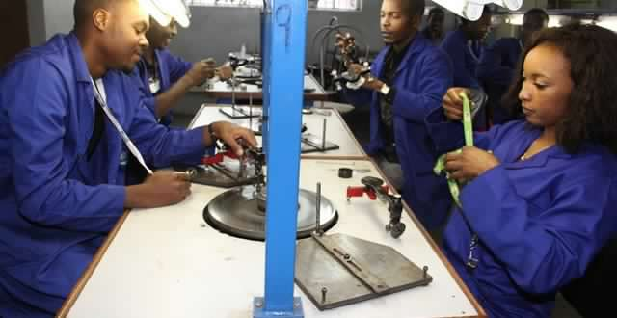

http://businessdaily.co.zw/index-id-Business-zk-36950.html

**Published: 23 July 2017**

Zimbabwean diamond cutting and polishing companies are struggling to absorb the mandated 10% market share set aside by government to encourage growth and development of the downstream industries, an official has said.  
  
As a policy intervention, government set aside 10% of all rough diamond stock for sale to the local cutting and polishing industry.  
  
But addressing delegates at the young professionals' forum held concurrently with the Mining, Engineering and Transport (Mine Entra) Expo in Bulawayo last Wednesday, Zimbabwe Consolidated Company (ZCDC) CEO Moris Mpofu said local companies were struggling to absorb the share allocated to them.  
  
"Due to capacity constraints, the local cutting and polishing companies are failing to absorb the allocated 10%," Dube said.  
  
"The major challenges that the local market is seized with include, working capital constraints, problems in certification of polished diamonds, lack of access to regional and international markets and a negative perception on Zimbabwe."  
  
There are more than 10 diamond cutting and polishing companies in Zimbabwe.  
  
According to reports, Zimbabwe's diamond beneficiation drive is in danger of becoming a pipe dream as local cutters and polishers continue to be side-lined in favour of foreign processors, while the precious gems continue to be flown to Antwerp and other destinations for valuation, grading and cutting.  
  
The government made a decision to pursue local value addition and beneficiation as key pillars of its economic revival and empowerment policy.  
  
Industry and Commerce minister Mike Bimha told the Mine Entra 2017 conference that government was considering reviewing the 10% market share upwards.  
  
"In order to promote and facilitate development of this important sub-sector, we think the desired context as envisaged in the ZimAsset, we will be announcing improvement from the 10% in the current statutory instrument once consultation within government are finalised, hopefully in the next month," Bimha said.  
  
"Companies are, therefore, encouraged to embrace and invest in local beneficiation for them to meet the required threshold."  
  
Mpofu said ZCDC, as the major producer of rough diamonds in Zimbabwe, was mandated by the Ministry of Mines and Mining Development to engage cutting and polishing companies in the diamond value addition industry to establish the requisite capacity in the sector and come up with strategies to grow the industry.  
  
He said an all stakeholders committee, which was spearheading the establishment of a one-stop diamond value management centre, was set up last month.  
  
The centre would house all diamond value chain industries and other support industries, he said.  
- the standard